HOW DO I APPLY FOR A BUILDING PERMIT?

Visit our online portal https://energovweb.carson.org/EnerGovProd/SelfService#/home

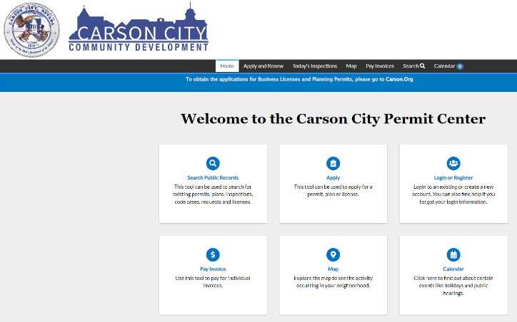

Create an online portal account. Please save your Username and Log-in; we cannot access your account if you get locked out.

Username __________________________

Password ___________________________

Choose the permit type that you need to apply for. Once the permit type is chosen, follow the workflow steps.

1-Enter location – Search- Add – if the address is correct- NEXT
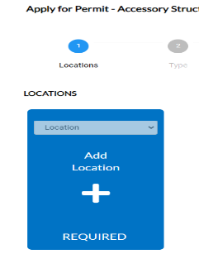
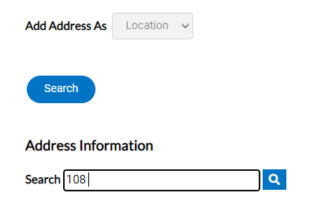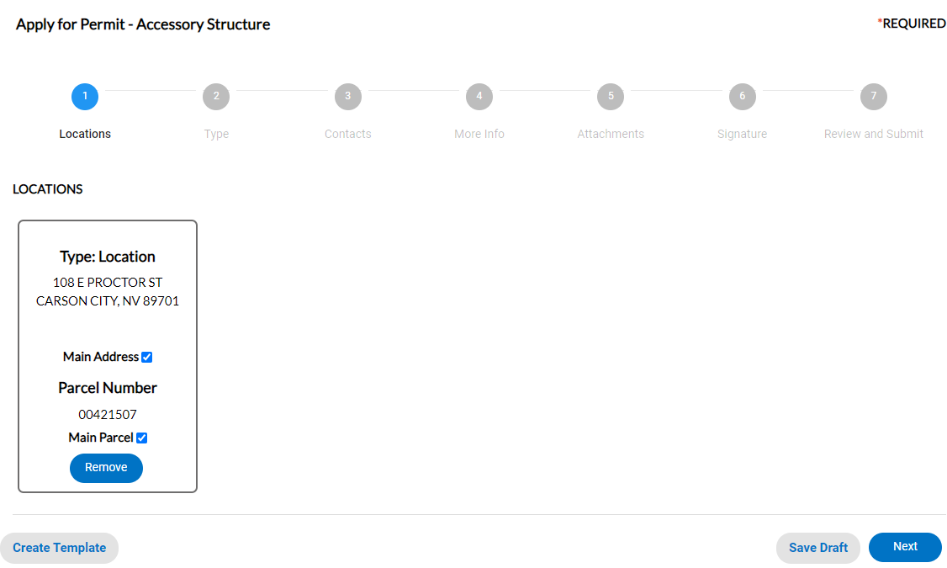

2-PERMIT DETAILS- Example below. Provide as many details as possible -NEXT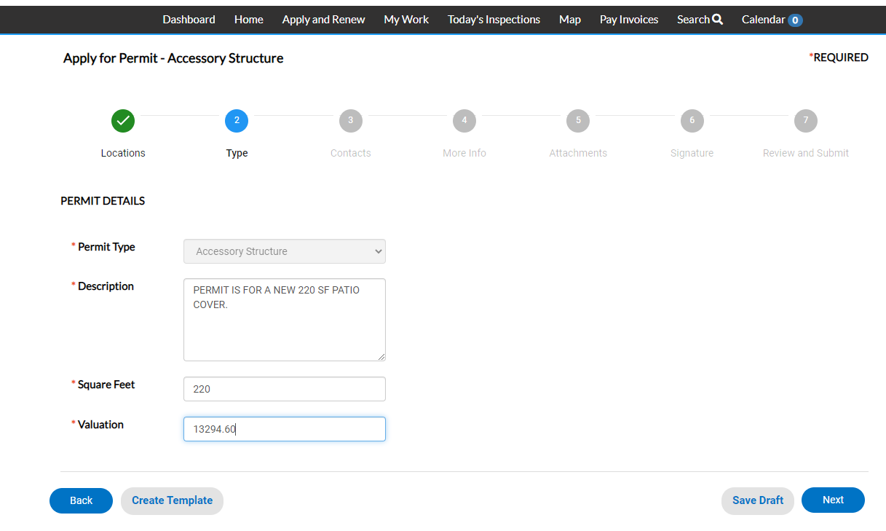
3-ADD CONTACTS- This should include the applicant, contractor, developer etc.- NEXT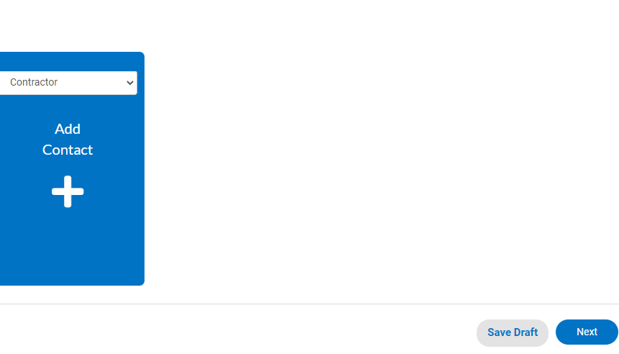

4-MORE INFO- NO NEED TO DO ANYTHING UNLESS ADDITONAL INFO IS REQUESTED- NEXT
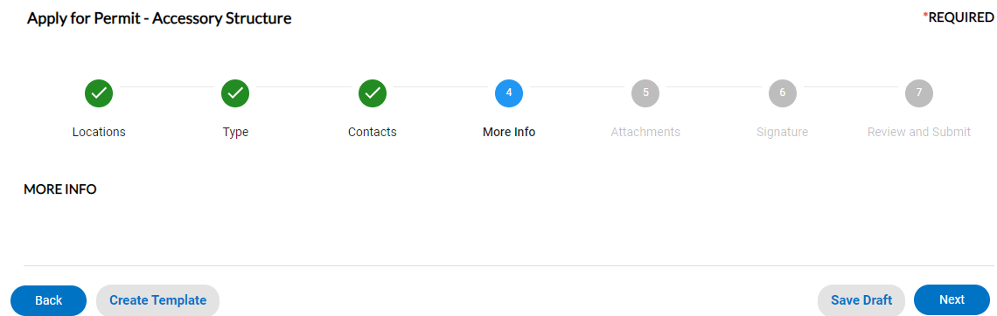

5-ADD ATTACHMENTS- Once all attachments are added- NEXT
Please use the following format:
Date- Description (01-01-22 PLAN SET, 01-01-22 STRUC. CALCS)
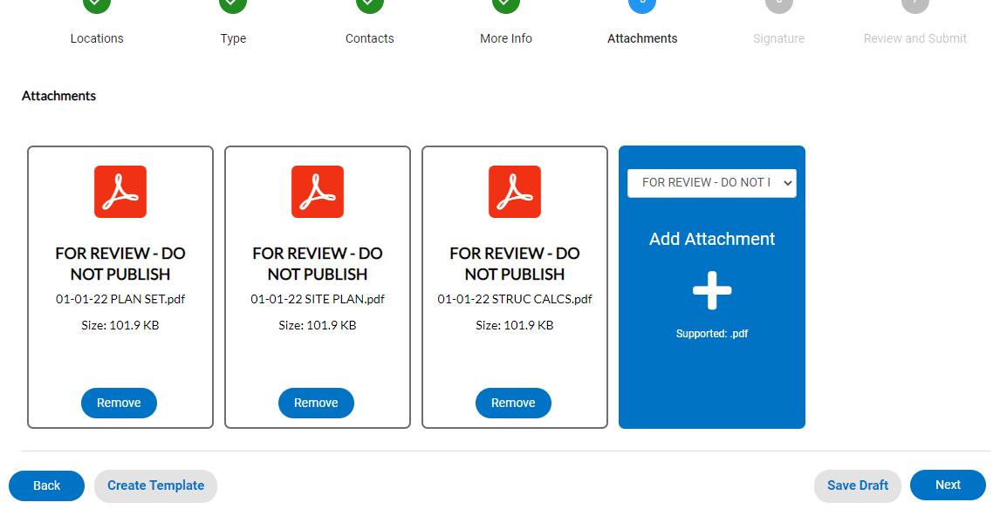

6-DIGITAL SIGNATURE- Sign- NEXT
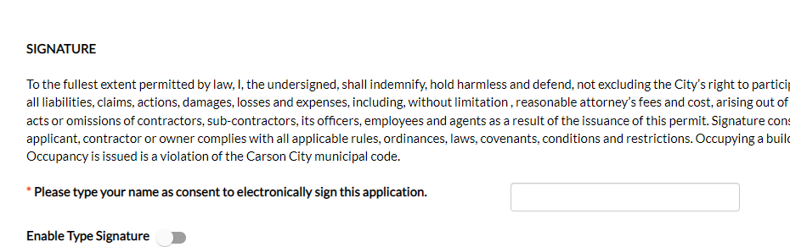

7-REVIEW AND SUBMIT- You have just created and submitted for your permit
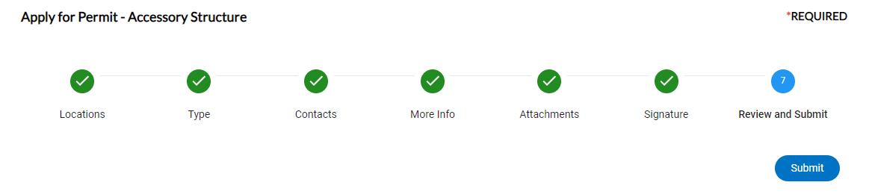
Use residential for residential projects and commercial for commercial projects: if you are unsure of the permit type, please call or email and ask. If the incorrect permit type is applied for, we will deny the permit and give direction to reapply. bldgdiv@carson.org 775-887-2310

